**Practical 10**

**SQL queries to implements various Date and Time functions on different data set and table data**

***Query1. Write SQL query to show current date and time using CURTIME (), CURDATE () function.***

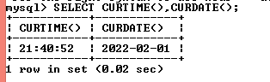

***Query2. Write SQL query to use MONTH (), MONTHNAME () function show month name and month number.***

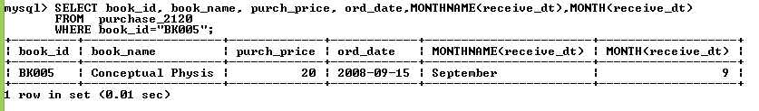

***Query3. Write SQL query to use DAYOFWEEK (), DAYNAME () function to show day number and day name in Product_2120, Sales_2120 table.***

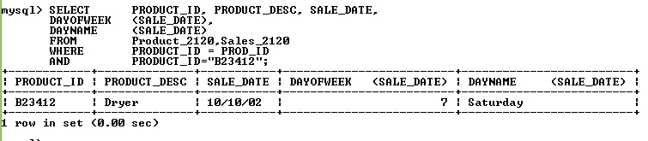

***Query4. Write SQL query to use ADDDATE () for add 10 days interval in order date of table purchase_2120.***

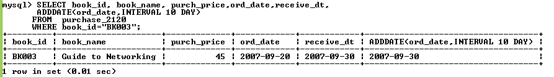

***Query5. Write SQL query to use DATE_ADD () function to add 12 Month interval in given date.***

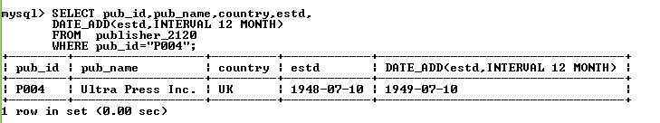

***Query6. Write SQL query to use TO_DAYS () in publisher_2120 table to show the total days from 0 to 1948-07-10 .***

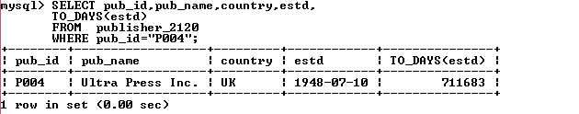

***Query7. Write SQL query to use FROM_DAYS () function in publisher_2120 table to show current date from given days 711683.***

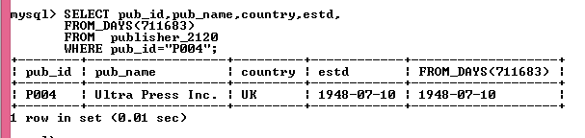

***Query8. Write SQL query to use MINUTE () function in EMP1_2120 table to show the minutes of given statement.***

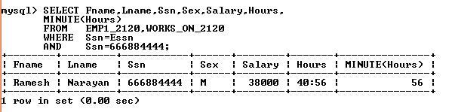

***Query9. Write SQL query to use HOUR () function in the EMP1_2120, WORKS_ON_2120 table to show the hours from the given statement.***

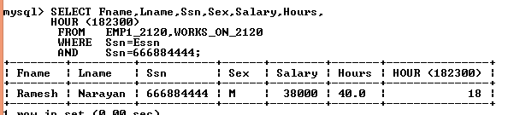

***Query10. Write SQL query to use DAYOFWEEK (), DAYNAME (), DAYOFYEAR (), DAYOFMONTH () function in Product_2120, Sales_2120 table.***

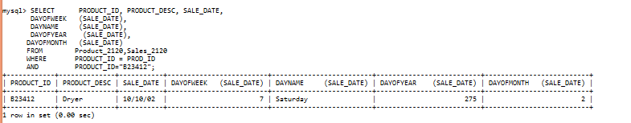

***Query11. Write SQL query to use DAYOFYEAR () in purchase_2120 table.***

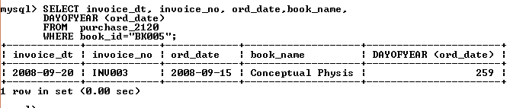

***Query12. Write SQL query to use DAYOFMONTH() in purchase_2120 table.***

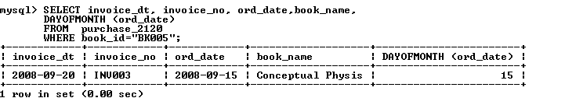

***Query13. Write SQL query to use DAYOFMONTH (), MONTHNAME (), DAYNAME () in EMP1_2120 table.***

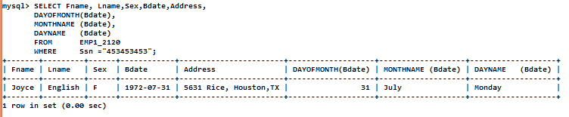

***Query14. Write SQL query to use DAYOFMONTH (), DAYNAME () in publisher_2120 table.***

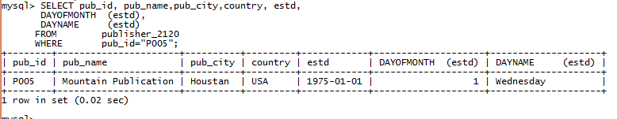

***Query15. Write SQL query to use*** ***DAYOFMONTH (), DAYNAME (), DAYOFYEAR () in the Product_2120, Sales_2120 table.***

